LanguageCert Test of English (LTE) Writing
Discount/promo code: 393E8E (for students registering in Poland)
C4163A (for students registering outside Poland)

Writing is a very important skill in the working environment and often underestimated. Prove to the recruiters and current supervisors that you can write in English in a working environment. Get your LTE Writing Certificate and include in your CV, online profile and portfolio!
LanguageCert LTE A1-C2 Exam:
- Designed specifically for university students approaching graduation and entering the workforce.
- Valid for life, does not expire!
- Offers Office English certification, which is essential for professionals in today's globalized job market.
- Available online, with the convenience and comfort of online administration, ensuring security and privacy.
- Adaptive in nature, providing a personalized experience that assesses your current level of knowledge and potential for growth.
- International recognition of your language skills, which can enhance your academic and professional career prospects.
- Demonstrates to employers your commitment to improving your language skills, making you a valuable asset in the job market.
- Enhances your confidence in using English in the workplace, allowing you to communicate effectively with colleagues and clients from around the world.
So, if you're a university student looking to boost your career prospects, consider taking the LanguageCert LTE A1-C2 Exam to demonstrate your language skills and set yourself apart in the job market!
Use this promo code to register with a discount, you can redeem the discount anywhere in the world!
Discount/promo code: 393E8E (for students registering in Poland)
C4163A (for students registering outside Poland)

Book your secure, online exam here: https://www.languagecert.org/en/language-exams/english/languagecert-test-of-english-lte/a1--c2-writing

EXAM STRUCTURE AND MAIN FEATURES
LTE Writing is a 1-hour test that you will take under the supervision of the exam administrator (proctor) online. You will write two passages, one communicative message of approximately 60-100 words and an extended piece of test in the form of a brief report, article or review. The test’s purpose is to verify your ability to produce writing about workplace matters. You will be asked to demonstrate proper level of grammar and vocabulary and coherent text organization.
APPLICATION of the LTE A1-C2 exam, why take LTE
LanguageCert Test of English (LTE) certificate will get you invited into a job interview faster! Recruiters from all over the world trust LanguageCert certifications and having any Certificate in your portfolio is always better than any ‘declaration’ of your English knowledge. Speaking in the English language is a very important skill at every turn of your academic and professional career.

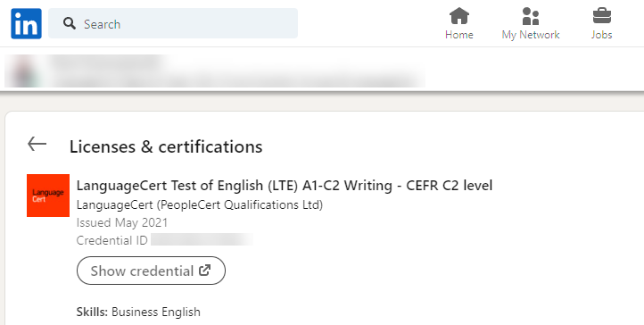

Help recruiters find and recruit you faster! LTE was designed to prove your ‘English survival skills’ in a working environment. You always pass the exam, your score is determined by your correct answers in a very modern, adaptive test format.

HOW TO REDEEM YOUR DISCOUNT/PROMO CODE

Discount/promo code: 393E8E (for students registering in Poland)
C4163A (for students registering outside Poland)
Book your secure, online exam here: https://www.languagecert.org/en/language-exams/english/languagecert-test-of-english-lte/a1--c2-writing
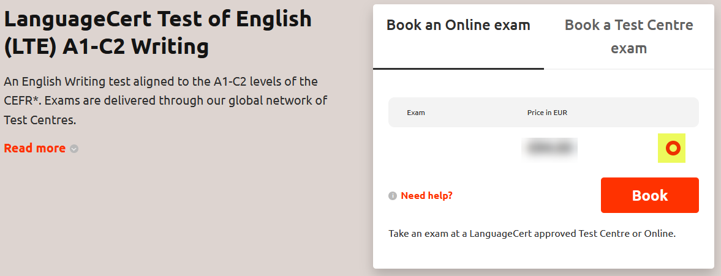
Select the red dot and click Book
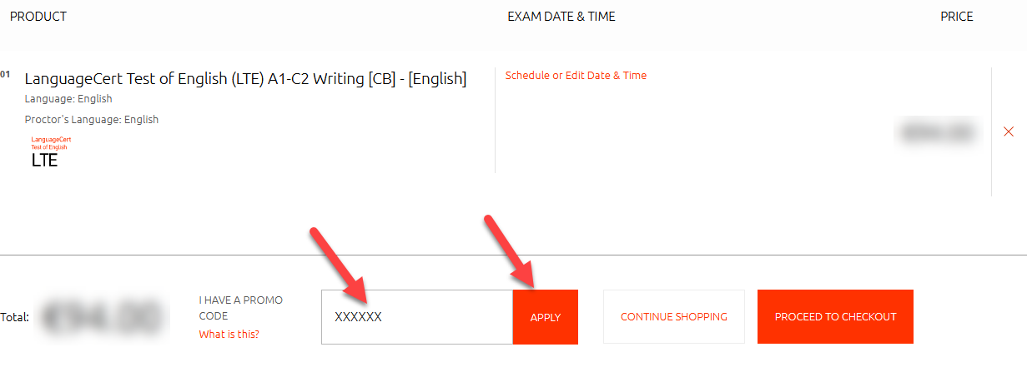
Enter your promo code and click Apply
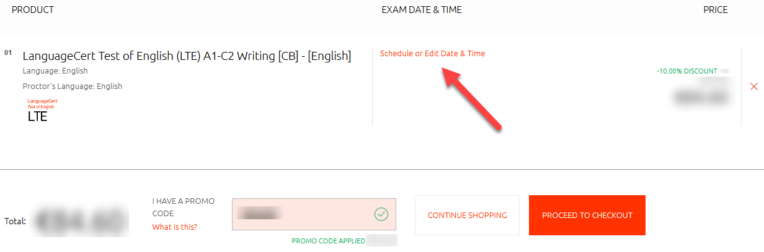
You will see the promo code applied and the discount (which may vary depending on the country our are registering from), click on Schedule or Edit Date & Time

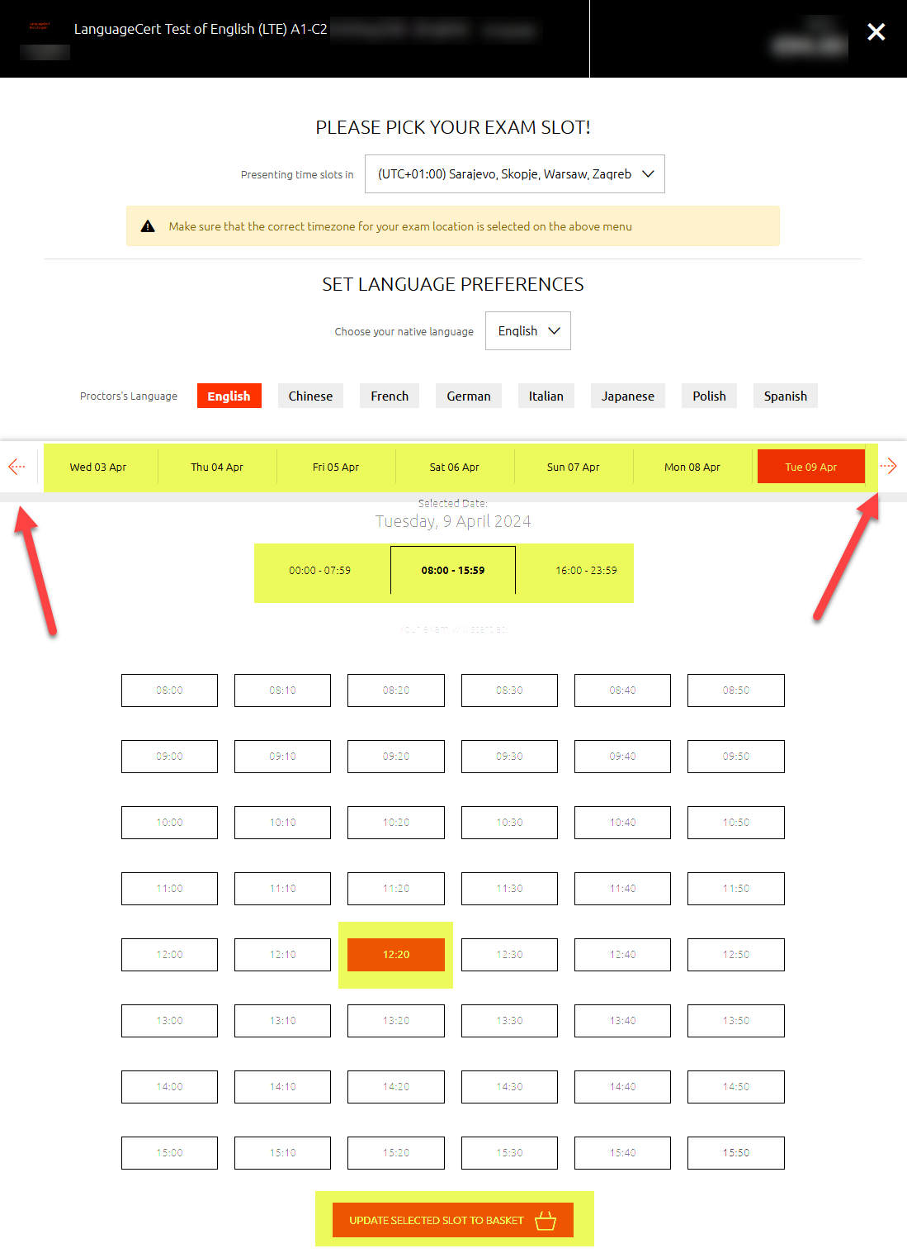

On this page you will be able to:
- Select the Proctor’s language (selecting your native language if available will help you with the admin part of the exam, your proctor will speak the language you select before starting the exam
- Use arrows to select the day of the exam (you have 12 months to decide when to take the exam)
- Select the start time of the exam
Finalize your selection and proceed to the checkout
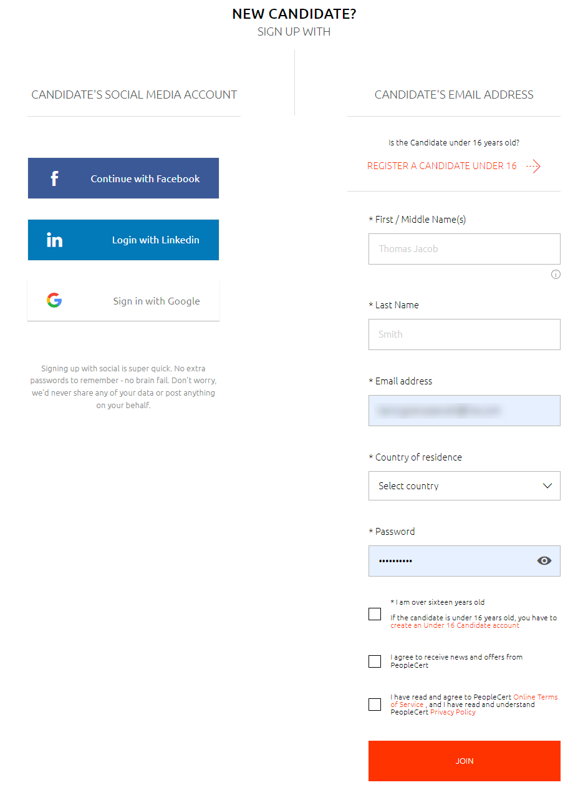
You will be asked to create your candidate’s account, fill in the required fields
The next step will be to complete the payment. You will receive booking confirmation and additional instructions via e-mail.
Tip: When you buy your exam, you will have 12 months from purchase to choose your exam date and time, depending on the availability of the exam slots.

PREPARATION
LanguageCert Test of English (LTE) preparation course!
Writing Test cracked!
If you're planning to take an Writing or ESPECIALLY if you're already registered for it, this course is perfect for you.
Your promo code for the course purchase: LAC494 will award you 30% discount!
Click here for the Writing module preparation course:
https://lynkoacademy.podia.com/lte-writing
Sample tests, sample exam papers
There are sample tests available on LanguageCert website, you can download the exam packs here: https://www.languagecert.org/en/language-exams/english/languagecert-test-of-english-lte/a1--c2-writing
… from the Official preparation material section of the website (scroll down on the page and expand).

Prepare your computer for the exam:
For your exam to be conducted successfully, you need to prepare your computer the right way, please see the guidelines below to help you prepare the technical part of the exam experience.
https://www.languagecert.org/en/exam-types/online-exams/olp-guidelines
Tip: Position your camera in such a way that you have the door to your room behind you so that the invigilator can see you and the door behind. Remove all the materials from your desk, put your phone on silent mode in case you will need to be contacted, do not switch it off entirely.

YOUR EXAM SCORES
You will receive a total score from 10 to 100 points. Depending on the number of points, you will see the CEFR level on your Report and Certificate as per below split:
C2 = 90-100 points
C1 = 75-89 points
B2 = 60-74 points
B1 = 40-59 points
A2 = 20-39 points
A1 = 10-19 points
0 = 0-9
WHAT WILL MY CERTIFICATE LOOK LIKE?
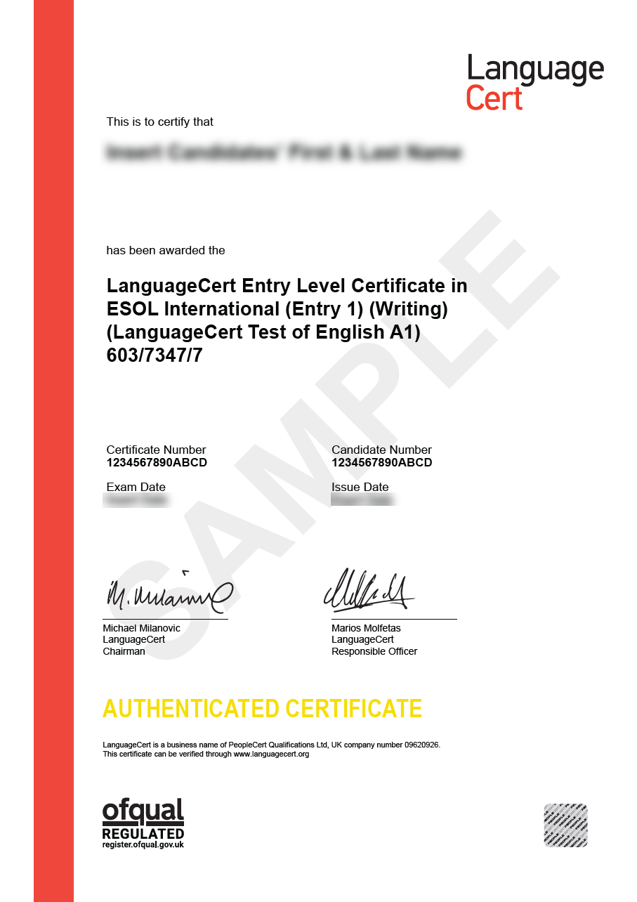

OTHER GREAT EXAM FEATURES

Online administration of the exams – Take LTE at home!
See the introductory clip here: https://youtu.be/E-YBTMH5RZo?si=VUBkAb2KgliKxEDq
Online Live Proctoring means you schedule an appointment with your exam administrator online and connect live to take the exam in a secure and comfortable environment of your own room. With this exam delivery method, you save time and money, you have great flexibility in selecting your exam date and time and you take the exam 1 on 1 with your exam administrator. No need to adjust your schedule to other candidates or test center availability.
Tip:
LTE exam is divided into three modules: Listening & Reading, Speaking and Writing, each offering a separate Certificate. You can decide which one to take first, for example: Listening & Reading is a great start of your journey to get over examination stress and have your first English Certificate. LTE Speaking however, tests the language skill that is often the most desired one in the world of working and communications. LTE Writing addresses a very important skill that you may want to show off to complete your journey with LTE suite of exams, Writing e-mails and chatting in English is now more important than ever!

Digital Badge from LanguageCert to boost your CV and profile!
You will surely impress your interviewer at your new job BUT the idea is to get invited! Adding the LanguageCert digital badge to your CV/resume and to your LinkedIn profile for example will definitely make you more visible in the pool of candidates. Once you pass your LanguageCert LTE, you will find your digital badge on your candidate’s profile, you can share or download your badge and use it to boost your profile!

